Excel Assignment – 16

- What is a Macro? How is it useful in excel or in your daily work?
A macro is a set of pre-recorded instructions or code used to automate repetitive tasks in software like Excel. In Excel, macros are created using VBA (Visual Basic for Applications) and can perform tasks such as formatting, calculations, or data manipulation automatically.
Usefulness:
- Time-saving: Speeds up repetitive tasks like formatting multiple sheets.
- Accuracy: Reduces errors in complex operations.
- Efficiency: Automates workflows like generating reports or organizing data.

2. What is VBA? Write its full form and briefly explain why VBA is used in
excel?
VBA stands for Visual Basic for Applications. It is a programming language built into Microsoft Office applications, including Excel.
Why VBA is used in Excel:
- Automation: To create macros that automate repetitive tasks.
- Customization: To build custom functions, forms, or tools.
- Integration: To link Excel with other applications or databases for data exchange.

3. How do you record a macro? Write detailed steps to create a macro to
automatically make the following table in bold and to create borders for

hi 78
hello 69
ineuron 45
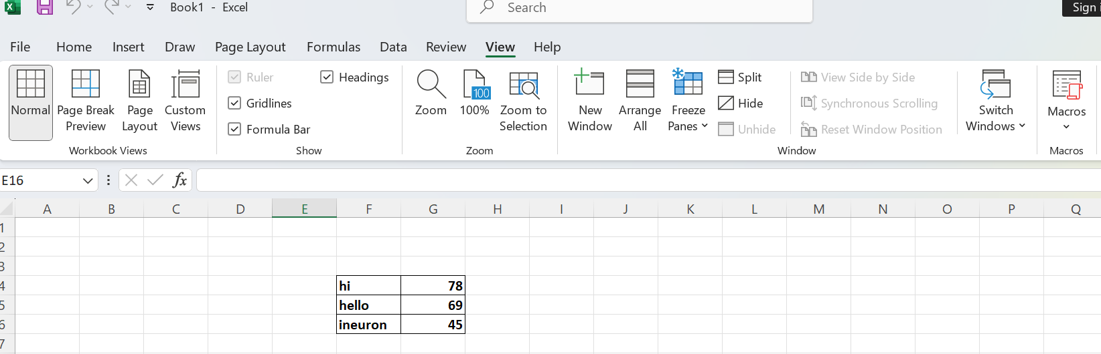
Steps to Create and Record a Macro in Excel:
- Enable Developer Tab:
  - Go to File > Options > Customize Ribbon > Check Developer > Click OK.
Record Macro:
- Go to view > Record Macro.
Create and Format Table:
- Enter the data (hi 78, hello 69, ineuron 45).
- Select the range (e.g., A1:B3).
- Press Ctrl + B for Bold.
- Apply All Borders from the Home tab.
Stop Recording:
- Go to VIEW > Stop Recording.
Run the Macro:
- Clear the sheet, go to view > Macros > Select FormatTable > Click Run.

4. What do you mean when we say VBA Editor?
The VBA Editor (Visual Basic for Applications Editor) is a tool within Microsoft Office applications like Excel, Word, and Access. It allows users to create, edit, and debug VBA (Visual Basic for Applications) code. This editor is used to develop macros, automate tasks, and create custom functions.
Key features of the VBA Editor include:
- Code Window: Write and edit VBA code.
- Project Explorer: View and manage all VBA projects in the workbook.
- Properties Window: Adjust properties of objects like forms or controls.
- Immediate Window: Test code snippets and debug.
To open it in Excel, press Alt + F11.

5. Briefly describe the interface of a VBA editor? What is properties
window? And what is watch window? How do you display these
windows?
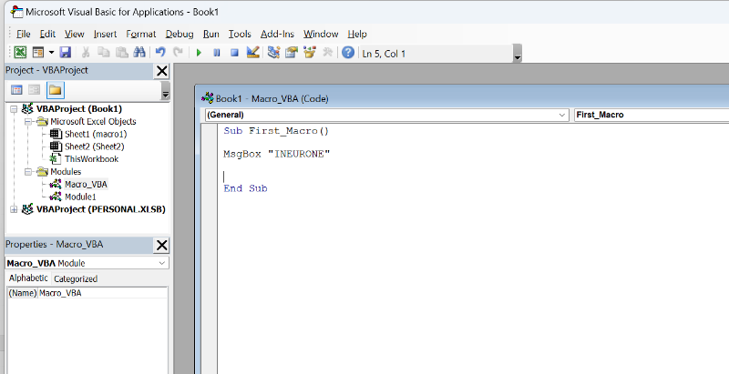

VBA Editor Interface:
- Menu/Toolbar: Access tools and options.
- Project Explorer: Shows all VBA projects and modules.
- Code Window: Write and edit VBA code.
- Properties Window: Edit object properties.
- Watch Window: Track variables during code execution.
- Immediate Window: Test code and debug.
Properties Window
- Edits properties of selected objects (e.g., forms, controls).
- Open with: View > Properties Window or F4.
Watch Window:
- Tracks variable values during debugging.
- Open with: View > Watch Window

7.What is an immediate Window and what is it used for?
The Immediate Window in the VBA Editor is a tool used to quickly test and run code, debug, and display output. You can use it to execute single lines of VBA code or check variable values during runtime.
How to Use:
- Open it with Ctrl + G or via View > Immediate Window.
- Example: Type ?Application.Name(ineurone) and press Enter to see the output.
